Fundamentals of MongoDB

CS 340 Client/Server Development

Nicholle Caudy

3/7/2025

* Open terminal

* Verify access to the environment

* Exit MongoDB and return to the Linux prompt

* Load the database

* Retrieve a document from the collection by executing commands in the mongo shell.

* Execute the command to find the size of a single document.

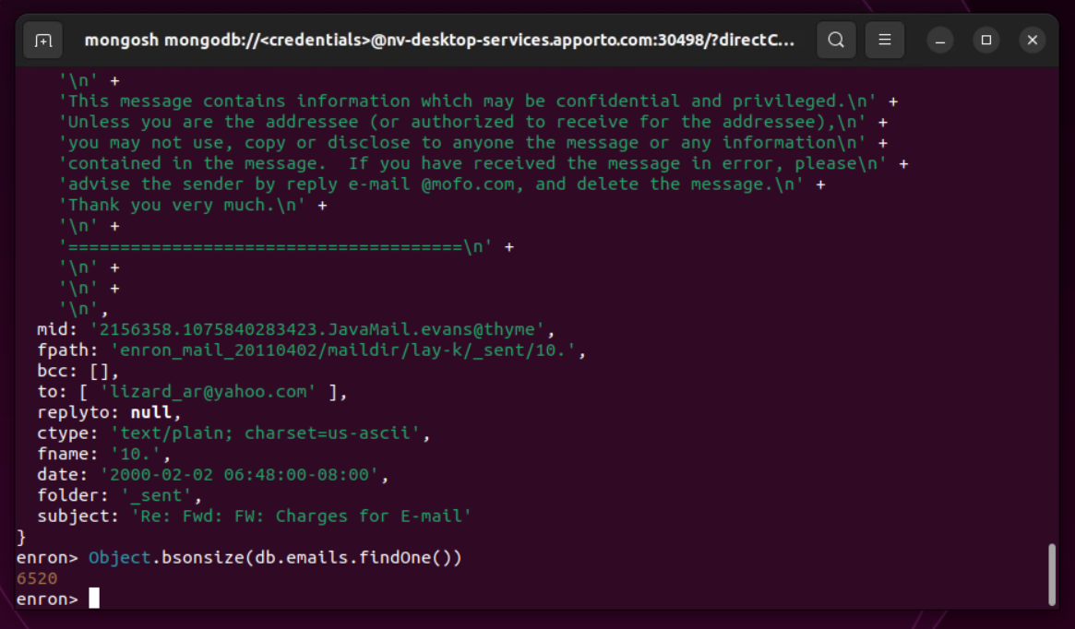

* Execute the command to find the size of the collection of documents

